SESSION -1 (KASHISH)
Q-1 Write a short paragraph in your own words defining what a 'program' is and give one real-life example from any app you use daily (like Instagram, Zomato, or Paytm)?
Ans. A program is a set of instructions written in a programming language that tells a computer or device what tasks to perform. It helps computers solve problems, process data, and automate activities according to the instructions given by the programmer.
For example, in Paytm, a program processes payments and updates account balances when I send or receive money.

Q-2 List three popular programming languages you have heard of, and for each, mention whether it is usually compiled, interpreted, or can be both. <br><br><em><strong>Hint:</strong> Think of languages like Java, Python, and JavaScript. </em>?
Ans. Java – Both (compiled and interpreted)
Python – Interpreted
JavaScript – Interpreted’

Q-3 Draw a flowchart (on paper or using any online tool) for the process of booking a movie ticket on BookMyShow, starting from opening the app to receiving the booking confirmation?
Ans.
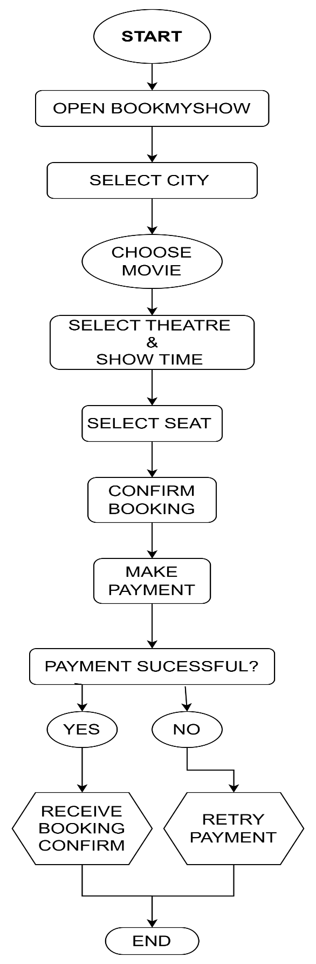
Q-4 Write down the steps (as an algorithm, using simple numbered instructions) for ordering food on Swiggy — from opening the app to completing payment.
Ans. Algorithm for Ordering Food on Swiggy
- Open the Swiggy app.
- Log in to your account.
- Enter or confirm your delivery location.
- Search for a restaurant or food item.
- Select the restaurant.
- Choose the food items you want to order.
- Add the selected items to the cart.
- Review your order in the cart.
- Click on Proceed to Checkout.
10 Select or confirm the delivery address.
11 Choose a payment method (UPI, card, wallet, etc.).
12 Complete the payment.
13 Receive order confirmation.
14 End.

Ans.

